Lawrence Artl

CS-255-21EW2

Assignment 3-2

November 07, 2021

A Process Model Evaluation for Hamp Crafts

When reviewing a process diagram for a system it is important to make note of not just the flow of the system itself, but how in depth the view of the diagram is. In the case of the included DFD for Hamp Crafts, we are looking at and reviewing the Level 0 diagram, which shows relationships between data stores, data sources, and generic processes. The more detailed process view comes at higher levels, but for now we are concerned with only the basic relationships shown.

**Describe Hamp Crafts’ current purchase and supply process:**

The diagram shows a basic view of the current storefront of Hamp Crafts. A customer order is received by the system, and then the customer is checked out. Once checked out, a shipping plan is sent to the carrier, who sends the carrier plan to the shipper. The checkout process also sends data about the order to the fulfill process, which sends a delivery plan on to the supplier choosing process. The fulfill order process is in touch with the supplier’s shipment schedule. Once a supplier is chosen, contract negotiations are sent to the supplier, who then sends the required information on to the shipper. A generic description of the whole process above would include the following information:

* 1. The customer, the supplier, the carrier, and the shipper are all data sources.
  2. There are four processes that handle the customer order from start to finish

**Determine the additional requirements needed to support an online storefront:**

In order to support an online storefront for Hamp Crafts, several additional processes will need to be integrated into the current system. These processes will allow customers to interact with the inventory themselves, and by utilizing the existing processes of the physical store, the purchase system will automate itself. Some processes for consideration are:

* 1. A “Browse Catalog” process, which will act as the window to the store inventory for the customer to view items
     1. This will connect to an “Inventory” data store
  2. A “Select for Purchase” process, to allow customers to add items they have viewed into a virtual shopping car
     1. The virtual shopping cart will be a data store that the customer has access to via the “Display Cart” process
  3. A “Display Cart” process, which will allow customers to view their cart, as well as remove items from the cart

In addition to the above processes, customers will need to be able to hold an account with the online store. This account information, as well as past purchases and order status, will be housed in a “Customer Accounts” data source. Customers will have access to this data source via the following processes:

1. “Modify Account”, which allows customers to change their personal information like address, name, and etc.
2. “Order Status” process, which facilitates requests to the “Customer Accounts” source regarding the status of purchases made by the customer. This data will be forwarded through another “Order Status” process to the “Shipper” data source to receive information directly from the shipper. This process will also update order status as updates are received from the Shipper.

Finally, to integrate a “backend” of the online site, there will be an “Admin” data source for administrators to access all customer related information. This will be done via:

1. “Modify Account” process will act as and intermediary for Admin accounts as well as Customer accounts; when logged into the system as Admin, users will have access to most customer information such as order status and account status
2. “Help” process, allowing admin and customers to connect via messaging within the system. This will also allow customers to contact Admin for help with ordering and other questions

**Determine how to integrate the new online storefront:**

My grandfather always said “if it isn’t broke, don’t fix it” (he also said “I cut it twice and it’s still too short” in regards to sawing lumber, so there’s that). Essentially, the system that Hamp Crafts has in place seems to work well for them and there’s no reason to migrate to a new system if an online storefront can be integrated relatively easily. While building from the ground up will allow developers to fix any system issues that may exist as well as more seamlessly integrate processes, being able to use what already exists will save money and time in the long run. Additionally, testing a completely new system could result in downtime of the whole system as bugs are worked out. This would be bad for even brick and mortar stores as they would now be reliant on the complete system working on all fronts. I believe the online storefront can be integrated into the current system with just a few additions, shown in the included DFD (below).

In conclusion, by using the existing system, Hamp Crafts can add an online storefront to service customers in other locations and still use their current supplier, shipper, and carrier. By creating an account for all customers Hamp Crafts will also have the ability to compile data on all sales, both online and in person. The addition of a few new processes, data stores, and databases will ultimately result in a faster and more efficient scaling than if the system was completely rebuilt from the ground up.

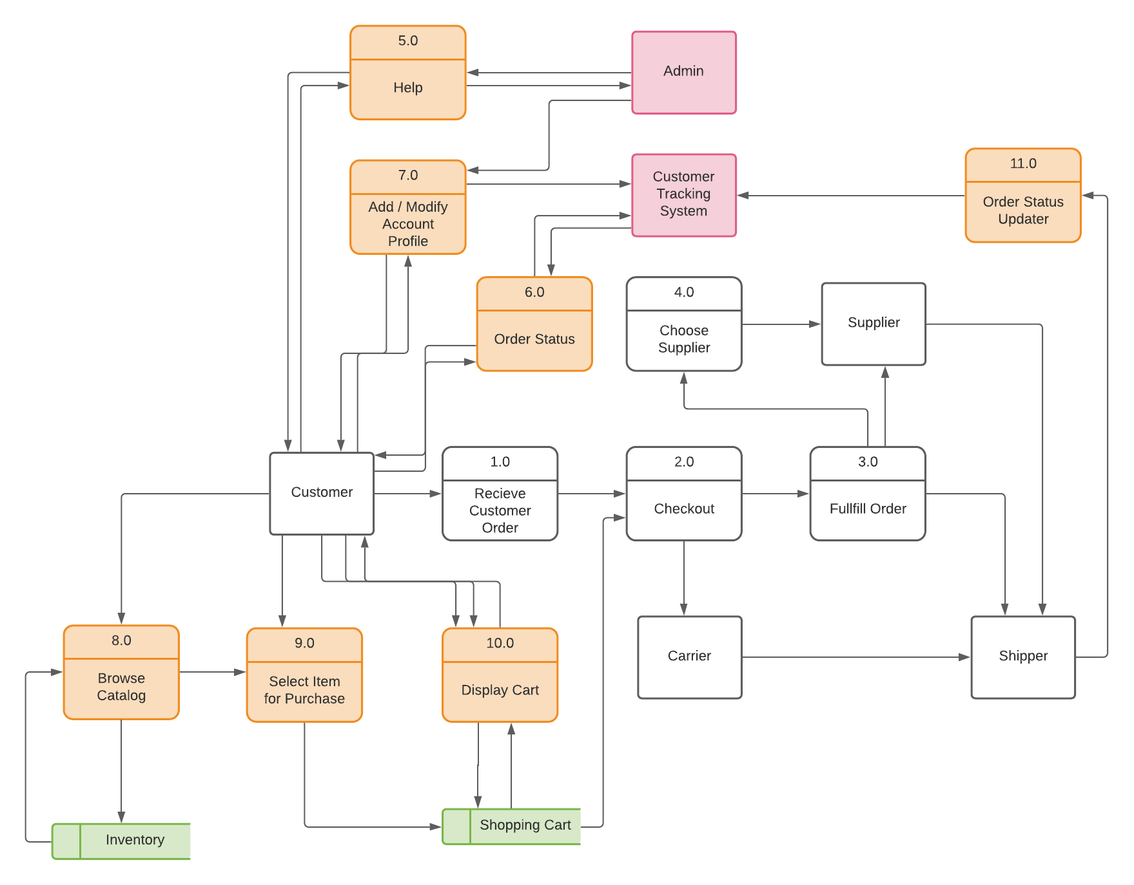

***Figure 1: A modified Level 0 DFD for Hamp Crafts’ Storefront***

*Note: data transfers are not labeled in order to save space*

Citations

Valacich J. S., & George J. F. (2019). Modern Systems Analysis and Design. [MBS Direct]. Retrieved from https://mbsdirect.vitalsource.com/#/books/9780135172841/